Міністерство освіти і науки України
Національний технічний університет України
«Київський політехнічний інститут імені Ігоря Сікорського»
Факультет інформатики та обчислювальної техніки
Кафедра обчислювальної техніки

Лабораторна робота №5
з дисципліни
«Об’єктно-орієнтоване програмування»
на тему
«Розробка багатовіконного інтерфейсу користувача для графічного редактора об’єктів»

Виконав: Перевірив:
студент групи ІМ-52 Рекечинський Д. О.
Опанасенко Владислав Костянтинович
Номер в списку - 12

Київ 2026
Завдання:
1. Створити у середовищі розробки проект з ім’ям Lab5.
2. Написати вихідний текст програми згідно варіанту завдання.
3. Скомпілювати вихідний текст і отримати виконуваний файл програми.
4. Перевірити роботу програми. За потреби налагодити програму.
5. Проаналізувати та прокоментувати результати та вихідний текст
програми.
6. Оформити звіт

Main file: main.py
import sys # noqa
import json
from typing import Type
from PySide6.QtCore import Qt
from PySide6.QtWidgets import (
QApplication,
QMainWindow,
QWidget,
QMenuBar,
QFileDialog,
QMessageBox,
)
from PySide6.QtGui import QAction, QActionGroup, QPen, QColor, QPainter, QIcon, QPalette
from shape_tools import Tool, TOOLS, ToolBase, SHAPE_CLASSES
from shape_table import ShapeWindow, shape_events
from repository import shape_repo
class Canvas(QWidget):
def __init__(self):
super().__init__()
self.pen = QPen(QColor("red"), 3, Qt.PenStyle.DashLine)
self.setAutoFillBackground(True)
palette = QPalette()
palette.setColor(QPalette.ColorRole.Window, QColor("white"))
self.setPalette(palette)
self.current_tool_class = TOOLS[Tool.FREEHAND]
self.active_tool = None
self.selected_shape = None
shape_events.on("shape_selected", self._handle_shape_selected)
shape_events.on("shape_removed", self._handle_shape_removed)
def _handle_shape_selected(self, shape_index: int):
shape = shape_repo.get_shape(shape_index)
self.selected_shape = shape
self.update()
def _handle_shape_removed(self):
shape_repo.remove_shape(self.selected_shape)
self.update()
def mousePressEvent(self, event):
if self.current_tool_class and event.button() == Qt.MouseButton.LeftButton:
self.active_tool = self.current_tool_class()
self.active_tool.press(self, event.position().toPoint())
def mouseMoveEvent(self, event):
if self.active_tool and event.buttons() == Qt.MouseButton.LeftButton:
self.active_tool.move(self, event.position().toPoint())
def mouseReleaseEvent(self, event):
if self.active_tool and event.button() == Qt.MouseButton.LeftButton:
self.active_tool.release(self, shape_repo, event.position().toPoint())
self.active_tool = None
def paintEvent(self, event):
painter = QPainter(self)
painter.setRenderHint(QPainter.RenderHint.Antialiasing)
painter.setPen(self.pen)
ToolBase.draw_finished(shape_repo, painter, self.selected_shape)
if self.active_tool:
self.active_tool.draw_preview(self, painter)
class ObjectsAction(QAction):
action_group = None
def __init__(self, text: str, parent, tool_class: Type[ToolBase], tip: str):
super().__init__(text, parent)
self._create_action_group(parent)
self.setCheckable(True)
self.setActionGroup(self.action_group)
self.setToolTip(tip)
self.tool_class = tool_class
self.triggered.connect(parent.set_current_tool)
@classmethod
def _create_action_group(cls, parent):
if cls.action_group is None:
cls.action_group = QActionGroup(parent)
class ObjectsMenu:
def __init__(self, menubar: QMenuBar):
self.menu = menubar.addMenu("Об’єкти")
def add_actions(self, actions: list[QAction]):
for action in actions:
self.menu.addAction(action)
class MainWindow(QMainWindow):
def __init__(self):
super().__init__()
self.setWindowTitle("Lab 5")
self.resize(800, 600)
self.canvas = Canvas()
self.setCentralWidget(self.canvas)
self.table_window = None
# self.show_table_window()
self._create_actions()
self._create_menubar()
self._create_toolbars()
def set_current_tool(self):
for action in self.objects_menu.menu.actions():
if action.isChecked() and isinstance(action, ObjectsAction):
self.canvas.current_tool_class = action.tool_class
def show_table_window(self):
if self.table_window is None:
self.table_window = ShapeWindow()
self.table_window.show()
self.table_window.raise_()
self.table_window.activateWindow()
def hide_table_window(self):
if self.table_window:
self.table_window.close()
def closeEvent(self, event) -> None:
if self.table_window:
self.table_window.close()
event.accept()
def save_file(self):
file_path, _ = QFileDialog.getSaveFileName(
self, "Зберегти як...", "shapes.json", "(*.json)"
)
if file_path:
shapes_data = []
for shape in shape_repo.get_shapes():
shapes_data.append(shape.to_dict())
try:
with open(file_path, "w") as file:
json.dump(shapes_data, file)
QMessageBox.information(
self, "Файл збережено", f"Файл збережено у {file_path}"
)
except Exception as e:
QMessageBox.critical(self, "Помилка", f"Не вдалося зберегти файл:\n{e}")
def load_file(self):
file_path, _ = QFileDialog.getOpenFileName(
self, "Відкрити файл", "", "(*.json)"
)
if file_path:
try:
with open(file_path, "r") as file:
shapes_data = json.load(file)
shape_repo.clear()
for shape_data in shapes_data:
shape_type = shape_data.pop("__type__")
shape_class = SHAPE_CLASSES[shape_type]
shape = shape_class.from_dict(shape_data)
shape_repo.add(shape)
self.canvas.update()
except Exception as e:
QMessageBox.critical(self, "Помилка", f"Не вдалося завантажити файл:\n{e}")
def _create_actions(self):
self.point_action = ObjectsAction(
"Крапка", self, TOOLS[Tool.FREEHAND], "Олівець"
)
self.point_action.setChecked(True)
self.line_action = ObjectsAction(
"Лінія", self, TOOLS[Tool.LINE], "Намалювати лінію"
)
self.rectangle_action = ObjectsAction(
"Прямокутник", self, TOOLS[Tool.RECTANGLE], "Намалювати прямокутник"
)
self.ellipse_action = ObjectsAction(
"Еліпс", self, TOOLS[Tool.ELLIPSE], "Намалювати еліпс"
)
self.line_with_circles_action = ObjectsAction(
"Лінія з кружечками",
self,
TOOLS[Tool.LINE_WITH_CIRCLES],
"Намалювати лінію з кружечками",
)
self.cube_action = ObjectsAction(
"Куб", self, TOOLS[Tool.CUBE], "Намалювати каркас куба"
)
self.point_action.setIcon(QIcon("../icons/pencil.svg"))
self.line_action.setIcon(QIcon("../icons/minus.svg"))
self.rectangle_action.setIcon(QIcon("../icons/rectangle.svg"))
self.ellipse_action.setIcon(QIcon("../icons/ellipse.svg"))
self.line_with_circles_action.setIcon(QIcon("../icons/linewithcircles.png"))
self.cube_action.setIcon(QIcon("../icons/box.svg"))
self.open_table_action = QAction(
"Відкрити таблицю", self, toolTip="Відкрити таблицю фігур"
)
self.open_table_action.setShortcut("Ctrl+T")
self.open_table_action.triggered.connect(self.show_table_window)
self.hide_table_action = QAction(
"Закрити таблицю", self, toolTip="Закрити таблицю фігур"
)
self.hide_table_action.triggered.connect(self.hide_table_window)
self.save_file_action = QAction("Зберегти", self, toolTip="Зберегти файл")
self.save_file_action.triggered.connect(self.save_file)
self.load_file_action = QAction("Відкрити", self, toolTip="Відкрити файл")
self.load_file_action.triggered.connect(self.load_file)
def _create_menubar(self):
menubar = self.menuBar()
self.file_menu = menubar.addMenu("Файл")
self.objects_menu = ObjectsMenu(menubar)
help_menu = menubar.addMenu("Довідка") # noqa
self.objects_menu.add_actions(
[
self.point_action,
self.line_action,
self.rectangle_action,
self.ellipse_action,
self.line_with_circles_action,
self.cube_action,
]
)
self.file_menu.addAction(self.save_file_action)
self.file_menu.addAction(self.load_file_action)
self.file_menu.addAction(self.open_table_action)
self.file_menu.addAction(self.hide_table_action)
def _create_toolbars(self):
toolbar = self.addToolBar("Shapes")
toolbar.addAction(self.point_action)
toolbar.addAction(self.line_action)
toolbar.addAction(self.rectangle_action)
toolbar.addAction(self.ellipse_action)
toolbar.addAction(self.line_with_circles_action)
toolbar.addAction(self.cube_action)
if __name__ == "__main__":
app = QApplication(sys.argv)
window = MainWindow()
window.show()
app.exec()

shape_tools.py
from enum import Enum, auto
from abc import ABC, abstractmethod
from contextlib import contextmanager
from typing import Generator, Type
from dataclasses import dataclass
from PySide6.QtGui import QColor
from PySide6.QtCore import QPoint, QRect
from PySide6.QtGui import QPainter, QPainterPath, QBrush, Qt, QPen
class Tool(Enum):
FREEHAND = auto()
LINE = auto()
RECTANGLE = auto()
ELLIPSE = auto()
LINE_WITH_CIRCLES = auto()
CUBE = auto()
class DrawnShape(ABC):
@abstractmethod
def draw(self, painter: QPainter, is_selected: bool = False) -> None: ...
@abstractmethod
def get_coords(
self,
) -> tuple[int, int, int, int]: ...
@abstractmethod
def to_dict(self) -> dict: ...
@classmethod
@abstractmethod
def from_dict(cls, data: dict) -> "DrawnShape": ...
def get_name_and_coords(self) -> tuple[str, int, int, int, int]:
coords = self.get_coords()
return SHAPE_NAMES[self.__class__], *coords
@dataclass
class DrawnPath(DrawnShape):
path: QPainterPath
def draw(self, painter: QPainter, is_selected: bool = False) -> None:
with ToolBase.shape_pen(painter, is_selected):
painter.drawPath(self.path)
def get_coords(self) -> tuple[int, int, int, int]:
start = self.path.pointAtPercent(0.0)
end = self.path.pointAtPercent(1.0)
return int(start.x()), int(start.y()), int(end.x()), int(end.y())
def to_dict(self) -> dict:
points = []
for i in range(self.path.elementCount()):
element = self.path.elementAt(i)
points.append((element.x, element.y))
return {
"__type__": "DrawnPath",
"points": points,
}
@classmethod
def from_dict(cls, data: dict) -> "DrawnPath":
path = QPainterPath()
points = [QPoint(x, y) for x, y in data["points"]]
start = points[0]
path.moveTo(start)
for point in points[1:]:
path.lineTo(point)
return cls(path)
@dataclass
class DrawnLine(DrawnShape):
path: QPainterPath
def draw(self, painter: QPainter, is_selected: bool = False) -> None:
with ToolBase.shape_pen(painter, is_selected):
painter.drawPath(self.path)
def get_coords(self) -> tuple[int, int, int, int]:
start = self.path.pointAtPercent(0.0)
end = self.path.pointAtPercent(1.0)
return int(start.x()), int(start.y()), int(end.x()), int(end.y())
def to_dict(self) -> dict:
start = self.path.pointAtPercent(0.0)
end = self.path.pointAtPercent(1.0)
return {
"__type__": "DrawnLine",
"start": (start.x(), start.y()),
"end": (end.x(), end.y()),
}
@classmethod
def from_dict(cls, data: dict) -> "DrawnLine":
start = QPoint(data["start"][0], data["start"][1])
end = QPoint(data["end"][0], data["end"][1])
path = QPainterPath()
path.moveTo(start)
path.lineTo(end)
return cls(path)
@dataclass
class DrawnRect(DrawnShape):
rect: QRect
def draw(self, painter: QPainter, is_selected: bool = False) -> None:
with ToolBase.shape_pen(painter, is_selected):
painter.drawRect(self.rect)
def get_coords(self) -> tuple[int, int, int, int]:
start = self.rect.topLeft()
end = self.rect.bottomRight()
return start.x(), start.y(), end.x(), end.y()
def to_dict(self) -> dict:
return {
"__type__": "DrawnRect",
"x": self.rect.x(),
"y": self.rect.y(),
"width": self.rect.width(),
"height": self.rect.height(),
}
@classmethod
def from_dict(cls, data: dict) -> "DrawnRect":
return cls(QRect(data["x"], data["y"], data["width"], data["height"]))
@dataclass
class DrawnEllipse(DrawnShape):
center: QPoint
rx: float
ry: float
start: QPoint
end: QPoint
def draw(self, painter: QPainter, is_selected: bool = False) -> None:
with ToolBase.shape_pen(painter, is_selected):
brush = QBrush(QColor("yellow"))
painter.setBrush(brush)
painter.drawEllipse(self.center, self.rx, self.ry)
painter.setBrush(Qt.BrushStyle.NoBrush)
def get_coords(self) -> tuple[int, int, int, int]:
return self.start.x(), self.start.y(), self.end.x(), self.end.y()
def to_dict(self) -> dict:
return {
"__type__": "DrawnEllipse",
"center": (self.center.x(), self.center.y()),
"rx": self.rx,
"ry": self.ry,
"start": (self.start.x(), self.start.y()),
"end": (self.end.x(), self.end.y()),
}
@classmethod
def from_dict(cls, data: dict) -> "DrawnEllipse":
center = QPoint(data["center"][0], data["center"][1])
rx = data["rx"]
ry = data["ry"]
start = QPoint(data["start"][0], data["start"][1])
end = QPoint(data["end"][0], data["end"][1])
return cls(center, rx, ry, start, end)
@dataclass
class DrawnLineWithCircles(DrawnShape):
start: QPoint
end: QPoint
radius: float
def draw(self, painter: QPainter, is_selected: bool = False) -> None:
with ToolBase.shape_pen(painter, is_selected):
painter.drawLine(self.start, self.end)
painter.drawEllipse(self.start, self.radius, self.radius)
painter.drawEllipse(self.end, self.radius, self.radius)
def get_coords(self) -> tuple[int, int, int, int]:
return self.start.x(), self.start.y(), self.end.x(), self.end.y()
def to_dict(self) -> dict:
return {
"__type__": "DrawnLineWithCircles",
"start": (self.start.x(), self.start.y()),
"end": (self.end.x(), self.end.y()),
"radius": self.radius,
}
@classmethod
def from_dict(cls, data: dict) -> "DrawnLineWithCircles":
start = QPoint(data["start"][0], data["start"][1])
end = QPoint(data["end"][0], data["end"][1])
radius = data["radius"]
return cls(start, end, radius)
@dataclass
class DrawnCube(DrawnShape):
front_start: QPoint
front_end: QPoint
def draw(self, painter: QPainter, is_selected: bool = False) -> None:
offset_x = (self.front_end.x() - self.front_start.x()) // 3
offset_y = (self.front_end.y() - self.front_start.y()) // 3
offset = QPoint(offset_x, -offset_y)
back_start = self.front_start + offset
back_end = self.front_end + offset
with ToolBase.shape_pen(painter, is_selected):
painter.drawRect(QRect(self.front_start, self.front_end))
painter.drawRect(QRect(back_start, back_end))
painter.drawLine(self.front_start, back_start)
painter.drawLine(
QPoint(self.front_end.x(), self.front_start.y()),
QPoint(back_end.x(), back_start.y()),
)
painter.drawLine(
QPoint(self.front_start.x(), self.front_end.y()),
QPoint(back_start.x(), back_end.y()),
)
painter.drawLine(self.front_end, back_end)
def get_coords(self) -> tuple[int, int, int, int]:
return (
self.front_start.x(),
self.front_start.y(),
self.front_end.x(),
self.front_end.y(),
)
def to_dict(self) -> dict:
return {
"__type__": "DrawnCube",
"front_start": (self.front_start.x(), self.front_start.y()),
"front_end": (self.front_end.x(), self.front_end.y()),
}
@classmethod
def from_dict(cls, data: dict) -> "DrawnCube":
front_start = QPoint(data["front_start"][0], data["front_start"][1])
front_end = QPoint(data["front_end"][0], data["front_end"][1])
return cls(front_start, front_end)
class ToolBase(ABC):
@abstractmethod
def press(self, widget, pos: QPoint) -> None: ...
@abstractmethod
def move(self, widget, pos: QPoint) -> None: ...
@abstractmethod
def release(self, widget, shape_repo, pos: QPoint) -> None: ...
@abstractmethod
def draw_preview(self, widget, painter: QPainter) -> None: ...
@staticmethod
def draw_finished(
shape_repo, painter: QPainter, selected: DrawnShape | None = None
) -> None:
for shape in shape_repo.get_shapes():
is_selected = shape is selected
shape.draw(painter, is_selected)
@staticmethod
@contextmanager
def shape_pen(painter: QPainter, is_selected: bool) -> Generator[None, None, None]:
last_pen = painter.pen()
color = QColor("red") if is_selected else QColor("black")
pen = QPen(color, 3)
painter.setPen(pen)
yield
painter.setPen(last_pen)
class FreehandTool(ToolBase):
def __init__(self):
self.path = None
def press(self, widget, pos: QPoint) -> None:
self.path = QPainterPath()
self.path.moveTo(pos)
def move(self, widget, pos: QPoint) -> None:
self.path.lineTo(pos)
widget.update()
def release(self, widget, shape_repo, pos: QPoint) -> None:
shape_repo.add(DrawnPath(self.path))
widget.update()
def draw_preview(self, widget, painter: QPainter) -> None:
if self.path:
painter.drawPath(self.path)
class LineTool(ToolBase):
def __init__(self):
self.start = None
self.end = None
def press(self, widget, pos: QPoint) -> None:
self.start = pos
def move(self, widget, pos: QPoint) -> None:
self.end = pos
widget.update()
def release(self, widget, shape_repo, pos: QPoint) -> None:
path = QPainterPath()
path.moveTo(self.start)
path.lineTo(pos)
shape_repo.add(DrawnLine(path))
widget.update()
def draw_preview(self, widget, painter: QPainter) -> None:
if self.start and self.end:
painter.drawLine(self.start, self.end)
class RectTool(ToolBase):
def __init__(self):
self.center = None
self.start = None
self.end = None
def press(self, widget, pos: QPoint) -> None:
self.center = pos
def move(self, widget, pos: QPoint) -> None:
half_width = abs(self.center.x() - pos.x())
half_height = abs(self.center.y() - pos.y())
self.start = QPoint(self.center.x() - half_width, self.center.y() - half_height)
self.end = QPoint(self.center.x() + half_width, self.center.y() + half_height)
widget.update()
def release(self, widget, shape_repo, pos: QPoint) -> None:
if self.start and self.end:
rect = QRect(self.start, self.end)
shape_repo.add(DrawnRect(rect))
widget.update()
def draw_preview(self, widget, painter: QPainter) -> None:
if self.start and self.end:
rect = QRect(self.start, self.end)
painter.drawRect(rect)
class EllipseTool(ToolBase):
def __init__(self):
self.start = None
self.end = None
self.center = None
self.rx = None
self.ry = None
def press(self, widget, pos: QPoint) -> None:
self.start = pos
def move(self, widget, pos: QPoint) -> None:
self.end = pos
self.rx = (self.end.x() - self.start.x()) // 2
self.ry = (self.end.y() - self.start.y()) // 2
self.center = QPoint(self.start.x() + self.rx, self.start.y() + self.ry)
widget.update()
def release(self, widget, shape_repo, pos: QPoint) -> None:
if self.center and self.rx and self.ry:
shape_repo.add(
DrawnEllipse(self.center, self.rx, self.ry, self.start, self.end)
)
widget.update()
def draw_preview(self, widget, painter: QPainter) -> None:
if self.center and self.rx and self.ry:
painter.drawEllipse(self.center, self.rx, self.ry)
class LineWithCirclesTool(LineTool, EllipseTool):
def __init__(self):
LineTool.__init__(self)
EllipseTool.__init__(self)
self.radius = 10
def release(self, widget, shape_repo, pos: QPoint) -> None:
if self.start and self.end:
shape_repo.add(DrawnLineWithCircles(self.start, self.end, self.radius))
widget.update()
def draw_preview(self, widget, painter: QPainter) -> None:
LineTool.draw_preview(self, widget, painter)
self.rx, self.ry = self.radius, self.radius
self.center = self.start
EllipseTool.draw_preview(self, widget, painter)
self.center = self.end
EllipseTool.draw_preview(self, widget, painter)
class CubeTool(RectTool, LineTool):
def __init__(self):
RectTool.__init__(self)
LineTool.__init__(self)
def release(self, widget, shape_repo, pos: QPoint) -> None:
if self.start and self.end:
shape_repo.add(DrawnCube(self.start, self.end))
widget.update()
def draw_preview(self, widget, painter: QPainter) -> None:
if self.start and self.end:
front_start = self.start
front_end = self.end
offset_x = (front_end.x() - front_start.x()) // 3
offset_y = (front_end.y() - front_start.y()) // 3
offset = QPoint(offset_x, -offset_y)
RectTool.draw_preview(self, widget, painter)
self.start = front_start + offset
self.end = front_end + offset
RectTool.draw_preview(self, widget, painter)
corners_front = (
front_start,
QPoint(front_end.x(), front_start.y()),
QPoint(front_start.x(), front_end.y()),
front_end,
)
corners_back = (
self.start,
QPoint(self.end.x(), self.start.y()),
QPoint(self.start.x(), self.end.y()),
self.end,
)
for front, back in zip(corners_front, corners_back):
self.start = front
self.end = back
LineTool.draw_preview(self, widget, painter)
self.start = front_start
self.end = front_end
TOOLS: dict[Tool, Type[ToolBase]] = {
Tool.FREEHAND: FreehandTool,
Tool.LINE: LineTool,
Tool.RECTANGLE: RectTool,
Tool.ELLIPSE: EllipseTool,
Tool.LINE_WITH_CIRCLES: LineWithCirclesTool,
Tool.CUBE: CubeTool,
}
SHAPE_CLASSES: dict[str, Type[DrawnShape]] = {
"DrawnPath": DrawnPath,
"DrawnLine": DrawnLine,
"DrawnRect": DrawnRect,
"DrawnEllipse": DrawnEllipse,
"DrawnLineWithCircles": DrawnLineWithCircles,
"DrawnCube": DrawnCube,
}
SHAPE_NAMES: dict[Type[DrawnShape], str] = {
DrawnPath: "Крива",
DrawnLine: "Лінія",
DrawnRect: "Прямокутник",
DrawnEllipse: "Еліпс",
DrawnLineWithCircles: "Лінія з кружечками",
DrawnCube: "Куб",
}

shape_table.py
from collections.abc import Callable
from PySide6.QtGui import QAction
from PySide6.QtCore import Qt, QModelIndex, QAbstractTableModel
from PySide6.QtWidgets import QTableView, QWidget, QVBoxLayout
class EventEmitter:
def __init__(self):
self._listeners: dict[str, list[Callable]] = {}
def on(self, event: str, func):
if event not in self._listeners:
self._listeners[event] = []
self._listeners[event].append(func)
return func
def emit(self, event: str, *args, **kwargs):
if event in self._listeners:
for listener in self._listeners[event]:
listener(*args, **kwargs)
shape_events = EventEmitter()
class ShapeTableModel(QAbstractTableModel):
_instance = None
_is_initialized = False
def __new__(cls, *args, **kwargs):
if cls._instance is None:
cls._instance = super().__new__(cls)
return cls._instance
def __init__(self):
if self._is_initialized:
return
super().__init__()
self._shapes = None
self._headers = ["Shape", "x1", "y1", "x2", "y2"]
self._is_initialized = True
def set_shapes_reference(self, shapes):
self._shapes = shapes
def rowCount(self, parent=None):
return len(self._shapes)
def columnCount(self, parent=None):
return len(self._headers)
def headerData(
self,
section: int,
orientation: Qt.Orientation,
role: int = Qt.ItemDataRole.DisplayRole,
) -> int | str | None:
if role == Qt.ItemDataRole.DisplayRole:
if orientation == Qt.Orientation.Horizontal:
if section < len(self._headers):
return self._headers[section]
return section
if orientation == Qt.Orientation.Vertical:
return section + 1
return None
def data(self, index, role=Qt.ItemDataRole.DisplayRole):
if role == Qt.ItemDataRole.DisplayRole:
shape = self._shapes[index.row()]
data = shape.get_name_and_coords()
return data[index.column()]
return None
class ShapeWindow(QWidget):
_instance = None
_is_initialized = False
def __new__(cls, *args, **kwargs):
if cls._instance is None:
cls._instance = super().__new__(cls)
return cls._instance
def __init__(self):
if self._is_initialized:
return
super().__init__()
self.setWindowTitle("Shapes Table")
self.resize(600, 600)
self.table_model = ShapeTableModel()
self.table_view = QTableView(self)
self.table_view.setModel(self.table_model)
self.table_view.clicked.connect(self._handle_click_cell)
self.table_view.verticalHeader().sectionClicked.connect(
self._handle_click_vertical_header
)
remove_action = QAction("Видалити фігуру", self)
remove_action.setShortcut("Delete")
remove_action.triggered.connect(self._handle_remove_action)
self.table_view.addAction(remove_action)
layout = QVBoxLayout()
layout.addWidget(self.table_view)
self.setLayout(layout)
self._is_initialized = True
@staticmethod
def _handle_click_cell(cell_index: QModelIndex):
shape_events.emit("shape_selected", shape_index=cell_index.row())
@staticmethod
def _handle_click_vertical_header(row: int):
shape_events.emit("shape_selected", shape_index=row)
@staticmethod
def _handle_remove_action():
shape_events.emit("shape_removed")

repository.py
from PySide6.QtCore import QModelIndex
from shape_tools import DrawnShape
from shape_table import ShapeTableModel
class ShapeRepository:
def __init__(self):
self._shapes = []
self.table_model = ShapeTableModel()
self.table_model.set_shapes_reference(self._shapes)
def get_shapes(self) -> list[DrawnShape]:
return self._shapes
def get_shape(self, index: int) -> DrawnShape:
return self._shapes[index]
def add(self, shape: DrawnShape):
new_row_index = len(self._shapes)
self.table_model.beginInsertRows(QModelIndex(), new_row_index, new_row_index)
self._shapes.append(shape)
self.table_model.endInsertRows()
def remove_shape(self, shape: DrawnShape):
if shape not in self._shapes:
return
shape_index = self._shapes.index(shape)
self.table_model.beginRemoveRows(QModelIndex(), shape_index, shape_index)
self._shapes.remove(shape)
self.table_model.endRemoveRows()
def clear(self):
self.table_model.beginResetModel()
self._shapes.clear()
self.table_model.endResetModel()
shape_repo = ShapeRepository()

Скріншоти

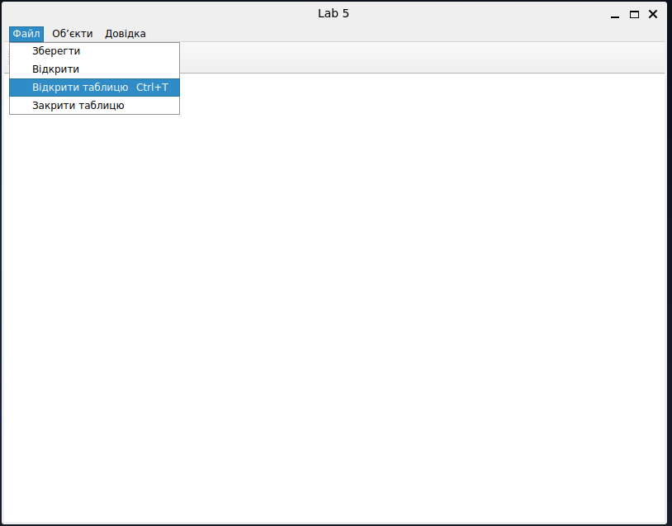
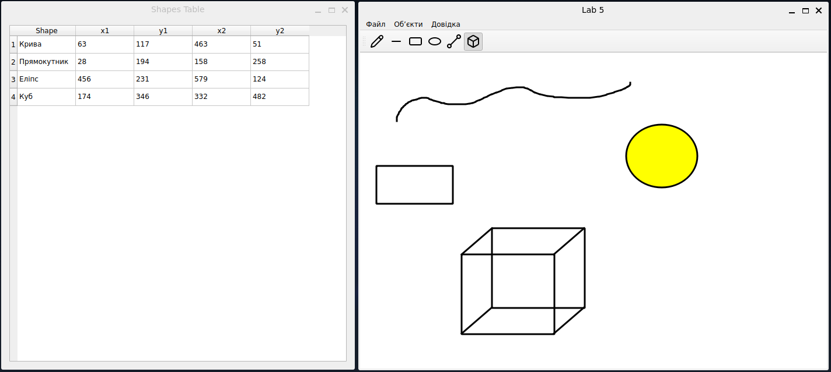
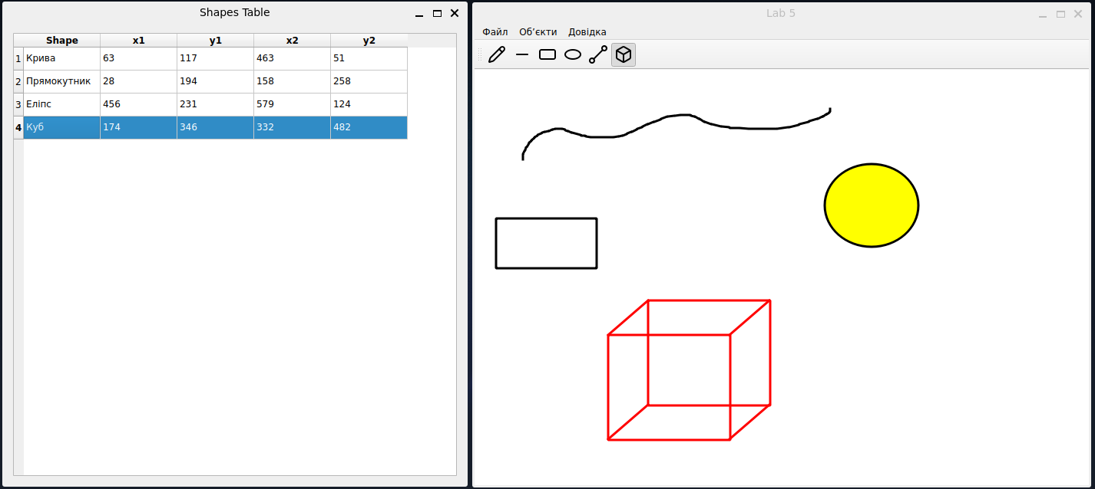
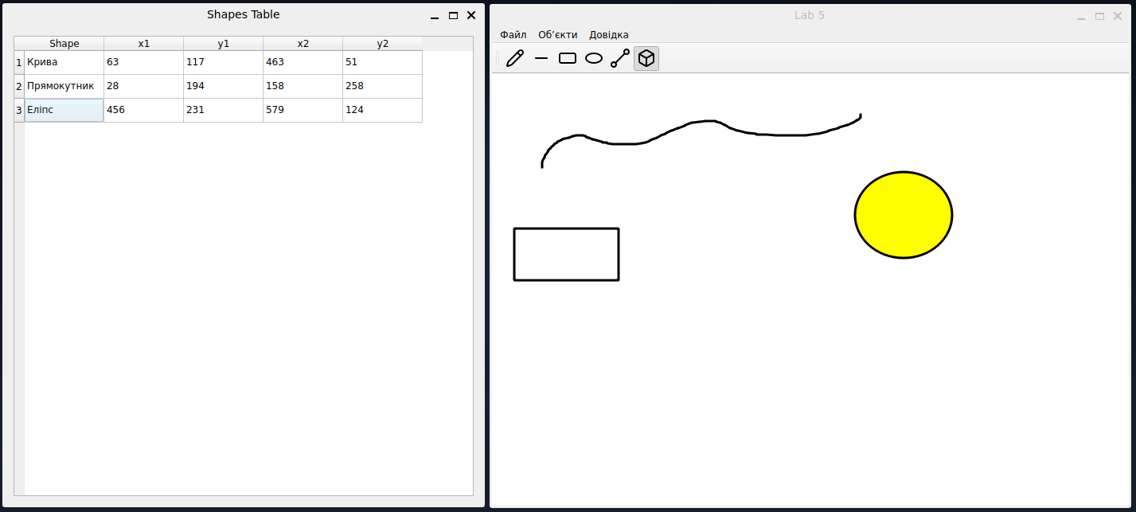
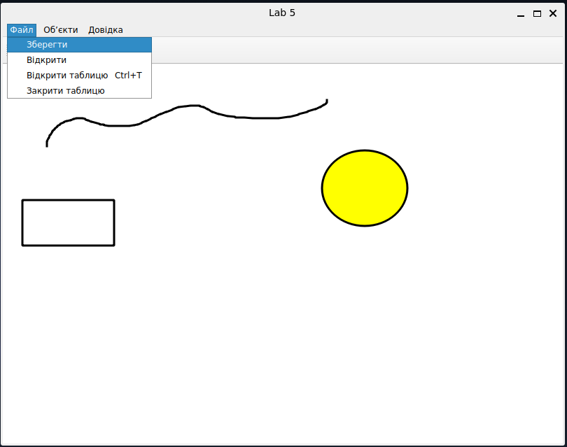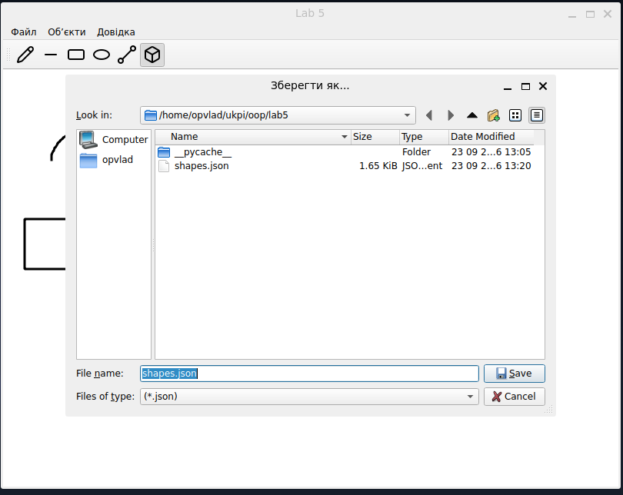
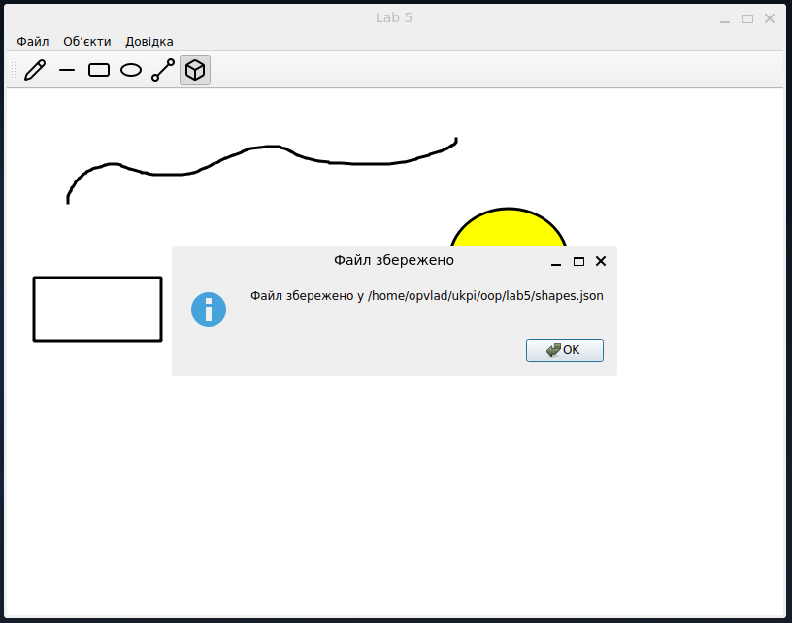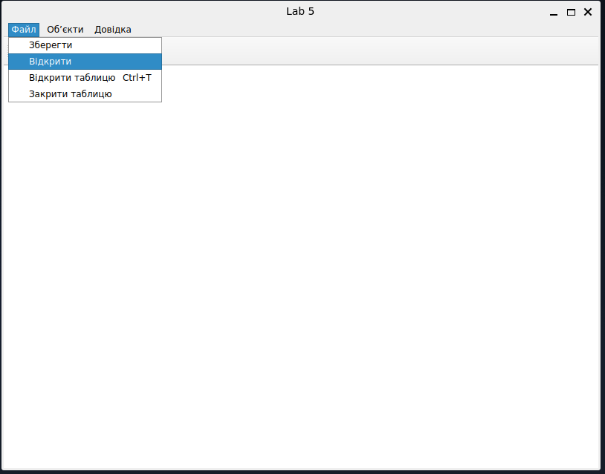
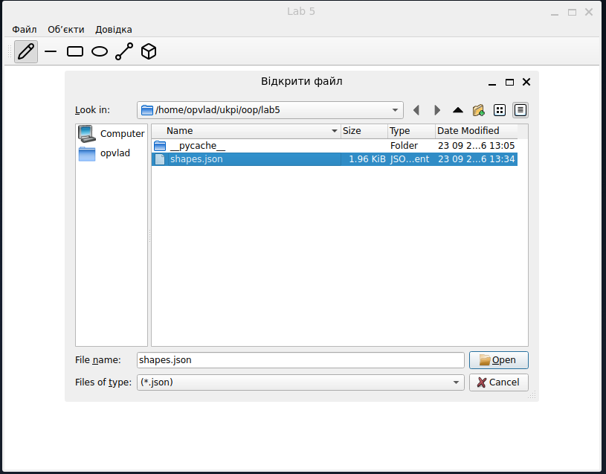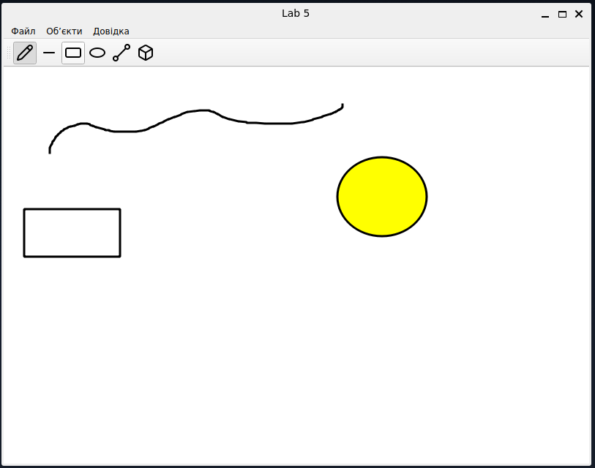

Діаграма класів:

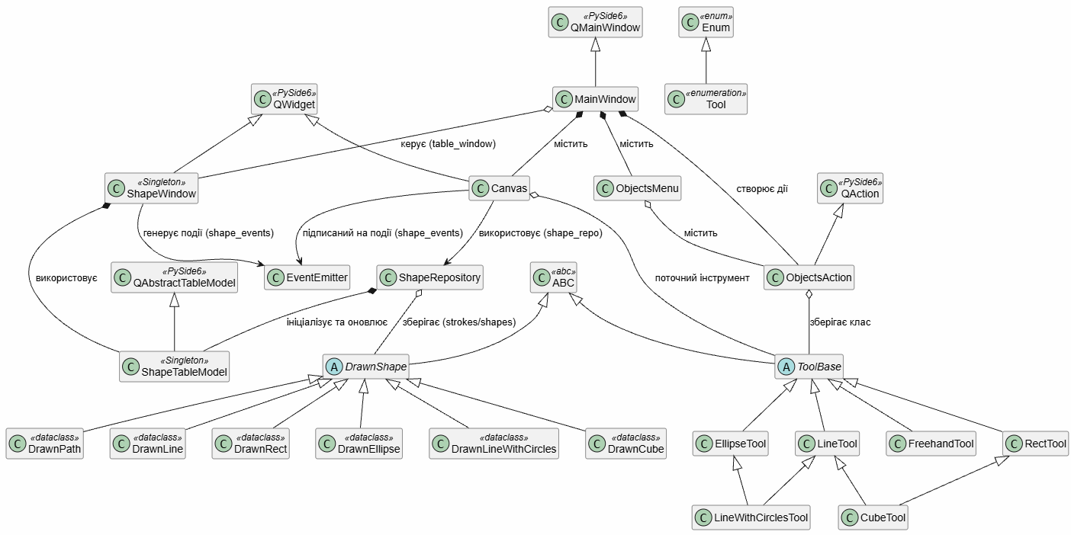

Висновки:
У лабораторній работі я виконав завдання згідно свого варіанту. Вдосконалив програму, яка є простим графічним редактором в об’єктно-орієнтованому стилі.
Навчився створювати немодальні вікна діалогу, таблиці, використовувати паттерни Singleton, Emitter/Listener.

